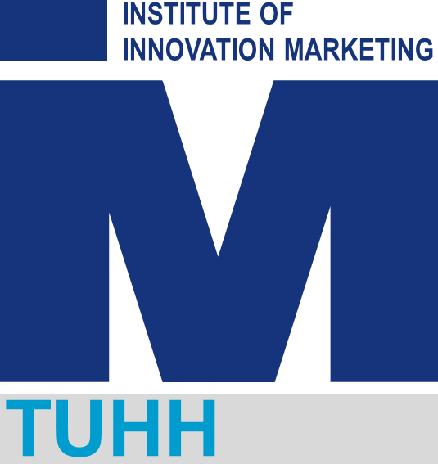

Guidelines for Writing a Research Exposé

Institute of Innovation Marketing (W-3)

Prof. Dr. Christian Lüthje
Head of Institute (W-3)
Hamburg University of Technology
Am Schwarzenberg-Campus 4
21073 Hamburg
Tel: 040-42878-4515 (Secretariat)
Fax: 040-4273-14479

Table of Contents

1. What is an exposé? 1
2. Structure 1
2.1 Abstract 1
2.2 Introduction 1
2.3 State of the art 2
2.4 Methods 2
2.5 Preliminary work (if applicable) 3
2.6 Work plan and time 3
2.7 References 4

1. What is an exposé?
An exposé is the first comprehensive written presentation of a research project. It is produced after the initial orientation and planning phase, and its purpose is to communicate all essential aspects of the proposed work in a concise, coherent, and academically rigorous way. The finished document serves as a thematic and methodological anchor throughout the project, giving both student and the supervisor a shared reference point from the beginning.

Submission requirements:
Students are required to submit an exposé before the thesis topic can be formally approved.
Formalities:
- Length: 4 to 5 pages of text (Arial 11pt, single-spaced, standard margins).
- Language: English (unless otherwise agreed with the supervisor).
- Format: PDF or Word document, submitted by email before the agreed deadline.

2. Structure
The exposé must follow the structure below. Each section has a specific function; do not omit any of them. The sections do not need to be equal in length, but each must be substantive.

2.1 Abstract
The abstract is a single, self-contained paragraph (150 to 200 words) that summarises the entire exposé. It must cover five elements:
- The research need or gap the thesis is addressing
- The research question
- The method or approach the thesis will use
- The expected results or contribution
- The practical or theoretical relevance of the work
Note:
- Write the abstract last, one cannot summarise what is not yet written.
- Avoid vague claims such as 'this thesis will contribute to the literature.' State specifically what kind of contribution the thesis is expected to make and for whom it is relevant.

2.2 Introduction
The introduction must bring the reader into the topic quickly and it must establish why the topic matters. A common mistake is to begin too broadly and arrive at the research question only at the very end. Instead, move toward the specific subject within the first paragraph.
In the introduction the student may:
- Outline a relevant technological, market, or regulatory development that motivates the research
- Briefly sketch the theoretical background or disciplinary context (e.g., innovation management, B2B marketing, sustainability transitions)
- State any personal or professional motivation for the topic, if relevant
The introduction should close with a clear statement of the research question and a brief indication of why answering it is relevant, whether for theory, practice, or policy.
Note:
- The research question should be formulated as a question, not as a topic label. 'Sustainable business models in SMEs' is a topic. 'How do SMEs in the manufacturing sector design sustainable business models under resource constraints?' is a research question.
- Relevance can be framed at multiple levels: societal (e.g., sustainability goals, digitalisation), industry-level (e.g., competitive pressures, market gaps), or academic (e.g., a theoretical debate or empirical gap).

2.3 State of the art
This section demonstrates the student’s command of the relevant literature and builds the academic case for the project. It is not a list of summaries of papers the student has read. Its function is argumentative, it should show that (a) prior work exists and is relevant, (b) there remains a gap or unresolved question, and (c) the project addresses that gap.
A well-structured state of the art typically does three things in sequence:
- Establishes what is already known in the relevant area (existing theories, frameworks, empirical findings)
- Identifies what remains contested, underexplored, or absent from the literature
- Positions the research question as a direct response to that gap
Given the thematic scope of the programme, relevant literature may come from innovation management, marketing theory, sustainability research, or management studies more broadly. The selection of sources should reflect a critical engagement with the field, not a comprehensive inventory of everything published.
Note:
- At this stage, 8 to 12 key references are sufficient. The student is not yet expected to have completed a full literature review.
- Prioritise peer-reviewed journal articles and edited academic volumes. Working papers and conference papers are acceptable if well-established. Do not rely primarily on textbooks.

2.4 Methods
The methods section explains how the student will answer the search question. The student must name the approach they intend to use and justify why it is appropriate for the question. The level of detail expected at this stage is not a full research design, but rather a methodologically informed statement of intent.
Depending on the project, the methods section may describe:
Qualitative approaches
- Case study research (single or multiple case; exploratory or explanatory)
- Semi-structured interviews or focus groups
- Document analysis or content analysis
Quantitative approaches
- Survey-based research with statistical analysis
- Secondary data analysis (e.g., patent data, firm-level databases)
- Experimental designs (e.g., vignette studies presenting respondents with systematically varied scenarios to isolate the effect of specific variables)
Conceptual or theoretical approaches
- Systematic literature review or bibliometric analysis
- Theoretical framework development or comparison
In all cases, briefly justify the methodological choice. Why is this method well-suited to answer the specific question? If it is planned to use existing data sources or databases, this should be mentioned. If the plan is to collect primary data, provide a preliminary indication of the sampling strategy.
Note
- Avoid vague statements such as 'I will use a mixed-methods approach' without specifying what that entails.

2.5 Preliminary work (if applicable)
If the student has already undertaken work that goes beyond initial reading and planning, describe it here. This may include:
- A systematic or scoping literature search already in progress
- Preliminary interviews or expert conversations conducted
- Access agreements with companies, archives, or data providers
- Pilot analyses or exploratory data work
This section is optional. If there is not a substantive preliminary work, this can be omitted.

2.6 Work plan and time
A preliminary work plan serves as evidence that the student has thought realistically about the scope and sequence of the research. For a thesis, a month-by-month schedule is appropriate. Within each month, list the main activities planned.
A typical Master's thesis timeline covers the following phases:
- Literature review and theoretical grounding
- Research design and data collection preparation
- Data collection or empirical work
- Analysis and interpretation
- Writing, revision, and finalisation

Note
- The timeline does not need to be a Gantt chart. A simple table or numbered list of monthly milestones is sufficient.
- Indicate the planned thesis submission date explicitly.

2.7 References
List all sources cited in the exposé. The list should already include the publications that are most central to the research question and theoretical framework, even if additional sources will be identified later.
Use a consistent citation style throughout. APA 7th edition is the default unless another style has been agreed with the supervisor. Every source in the reference list must be cited in the text, and every in-text citation must appear in the reference list.

